# **Case Study – Healthcare Analysis**

## 1. Introduction

The healthcare industry generates vast amounts of data every day—from patient demographics and medical conditions to billing records and treatment details. Analyzing this data helps hospitals and healthcare providers improve patient care, reduce costs, and enhance overall operational efficiency. This case study leverages a healthcare dataset to extract insights that can guide better decision-making.

## 2. Business Problem Statement

Hospitals often struggle with managing patient inflow, controlling medical expenses, and ensuring timely treatment. Without proper analysis, it becomes difficult to identify trends in admissions, billing, insurance usage, and resource allocation. This lack of visibility can lead to longer patient stays, higher costs, and inefficient hospital operations.

## 3. Objective

To analyze patient records and hospital management data in order to identify patterns in demographics, billing, admissions, and medical conditions. The goal is to provide actionable insights that support improved healthcare delivery, optimized resource utilization, and cost management.

## 4. Key Business Questions

1. What is the demographic distribution of patients by age?
2. How does the average billing amount vary by insurance provider and admission type?
3. Which medical condition has the highest number of patients?
4. What is the gender-based demographic distribution of patients across different hospitals?
5. What are the most common medical conditions and their associated test results?

## 5. Dataset Description (Data Dictionary)

| Field Name | Data Type | Description |
| --- | --- | --- |
| Name | Text | Patient’s full name. |
| Age | Integer | Age of the patient in years. |
| Gender | Text | Gender of the patient (Male/Female/Other). |
| Blood Type | Text | Patient’s blood group (e.g., A+, O-, AB+). |
| Medical Condition | Text | Diagnosed health condition of the patient. |
| Date of Admission | Date | Date when the patient was admitted to the hospital. |
| Doctor | Text | Name of the doctor assigned to the patient. |
| Hospital | Text | Name of the hospital where the patient is admitted. |
| Insurance Provider | Text | Insurance company covering the patient’s expenses. |
| Billing Amount | Decimal | Total billing amount charged to the patient. |
| Room Number | Integer | Room assigned to the patient during admission. |
| Admission Type | Text | Type of admission (Emergency, Routine, Urgent, etc.). |
| Discharge Date | Date | Date when the patient was discharged. |
| Medication | Text | Medicines prescribed to the patient during treatment. |
| Test Results | Text | Diagnostic test results (Normal/Abnormal or detailed notes). |

## 6. Methodology

Steps followed for analysis: 1. Data Cleaning: Removed duplicates, handled missing values. 2. Exploratory Data Analysis: Checked patient distribution by demographics, admission type, billing, and medical condition. 3. Visualization: Created pivot tables/charts for patient counts, billing, and test results. 4. Key Business Questions: Addressed each question using data analysis. 5. Analysis Approach: Systematic observation of data to derive insights and actionable recommendations.

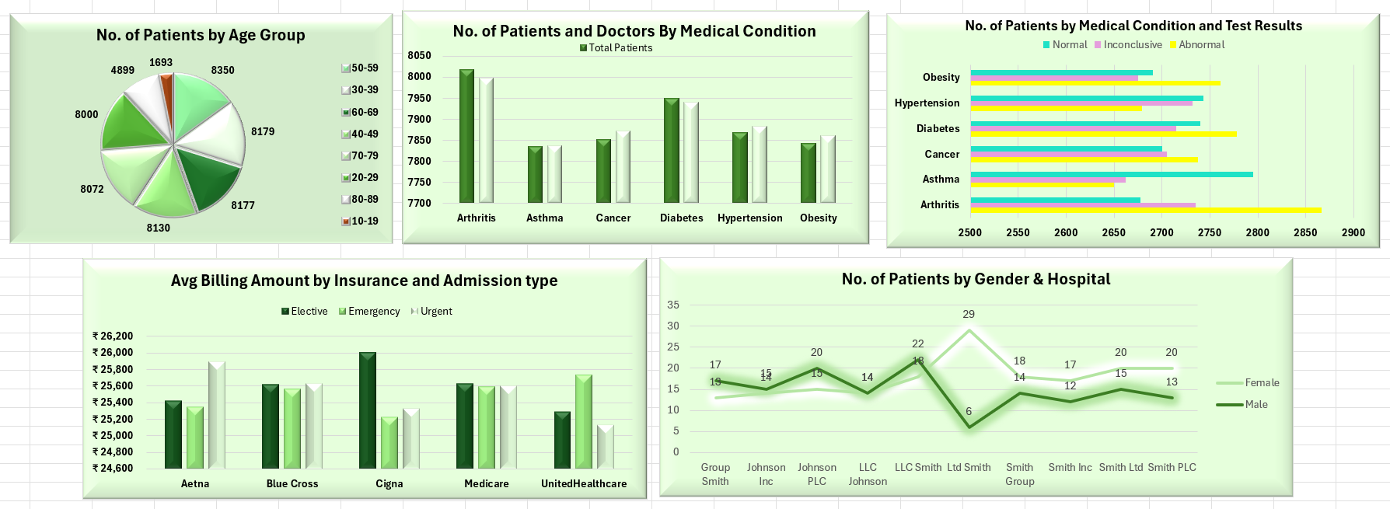

## 7. Analysis & Observations

1. Demographic Distribution by Age - 50–59 age group has the highest admissions; 10–19 the lowest. - 20–79 age groups have relatively even patient counts. - Slight drop in 80–89 age group.

2. Average Billing by Insurance Provider & Admission Type - Billing mostly consistent across providers. - Cigna highest for elective, Aetna for urgent, UnitedHealthcare for emergency admissions.

3. Most Common Medical Conditions - Arthritis has the highest patient count. - Diabetes and Hypertension follow closely; other conditions similar.

4. Gender Distribution Across Hospitals - Most hospitals admit slightly more males. - Ltd Smith has more females, LLC Smith more males. - LLC Johnson shows perfect gender balance.

5. Test Results by Medical Condition - Arthritis shows most abnormal results. - Other conditions have balanced normal and abnormal results.

## 8. Insights

* Age: 30–59 age group dominates; healthcare demand spans nearly all ages.
* Billing: Mostly standardized; urgent admissions slightly higher, minor insurance influence.
* Medical Conditions: Arthritis most prevalent; resources should be allocated fairly across conditions.
* Gender: Distribution varies; hospitals may need targeted planning.
* Test Results: Arthritis has highest abnormal outcomes; other conditions balanced, guiding follow-ups and resource allocation.

## 9. Conclusion

The analysis highlights patient trends, billing patterns, common medical conditions, and gender distribution. These insights can help optimize resources, improve patient care, and support data-driven healthcare decisions.